PROJECT NO. 3

**A machine named Metasploit framework given to you.**  
  
**Task 1:**Login to Metasploit and extract Ip address  
**Task 2:** Do Nmap scanning on the IP, Extract Open port and Version Details  
**Task 3:**Check the vulnerable version exploitation's procedure in rapid7 and start exploiting the following ports  
A) Telnet  
B) FTP  
C) SSH

Task 1:

Download metasploit2 and open.

Then Login to Metasploit and extract Ip address

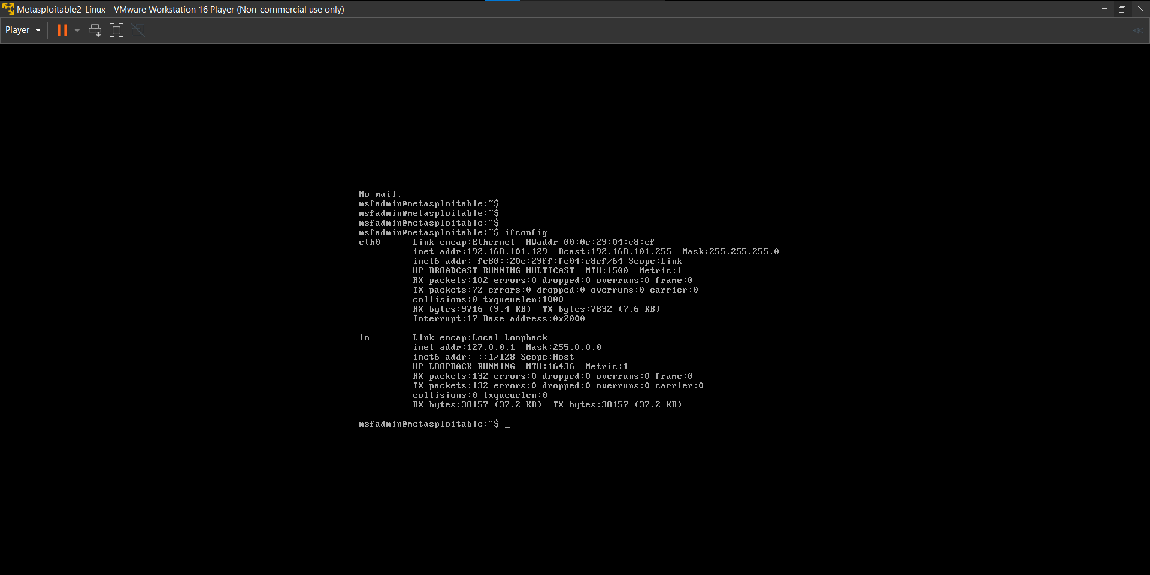

Task 2:

Do Nmap scanning on the IP, Extract Open port and Version Details

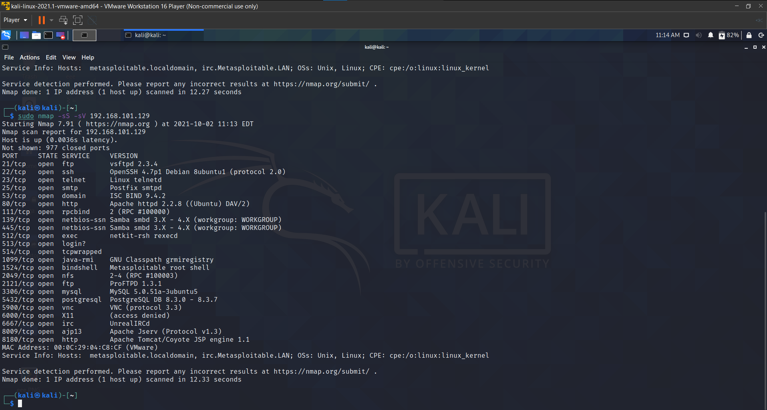

Task 3:

Check the vulnerable version exploitation's procedure in rapid7 and start exploiting the following ports  
A) Telnet  
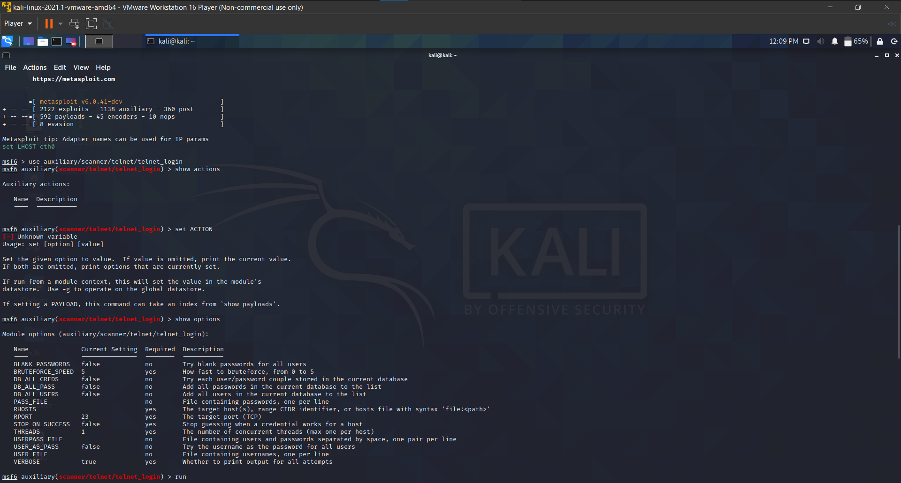

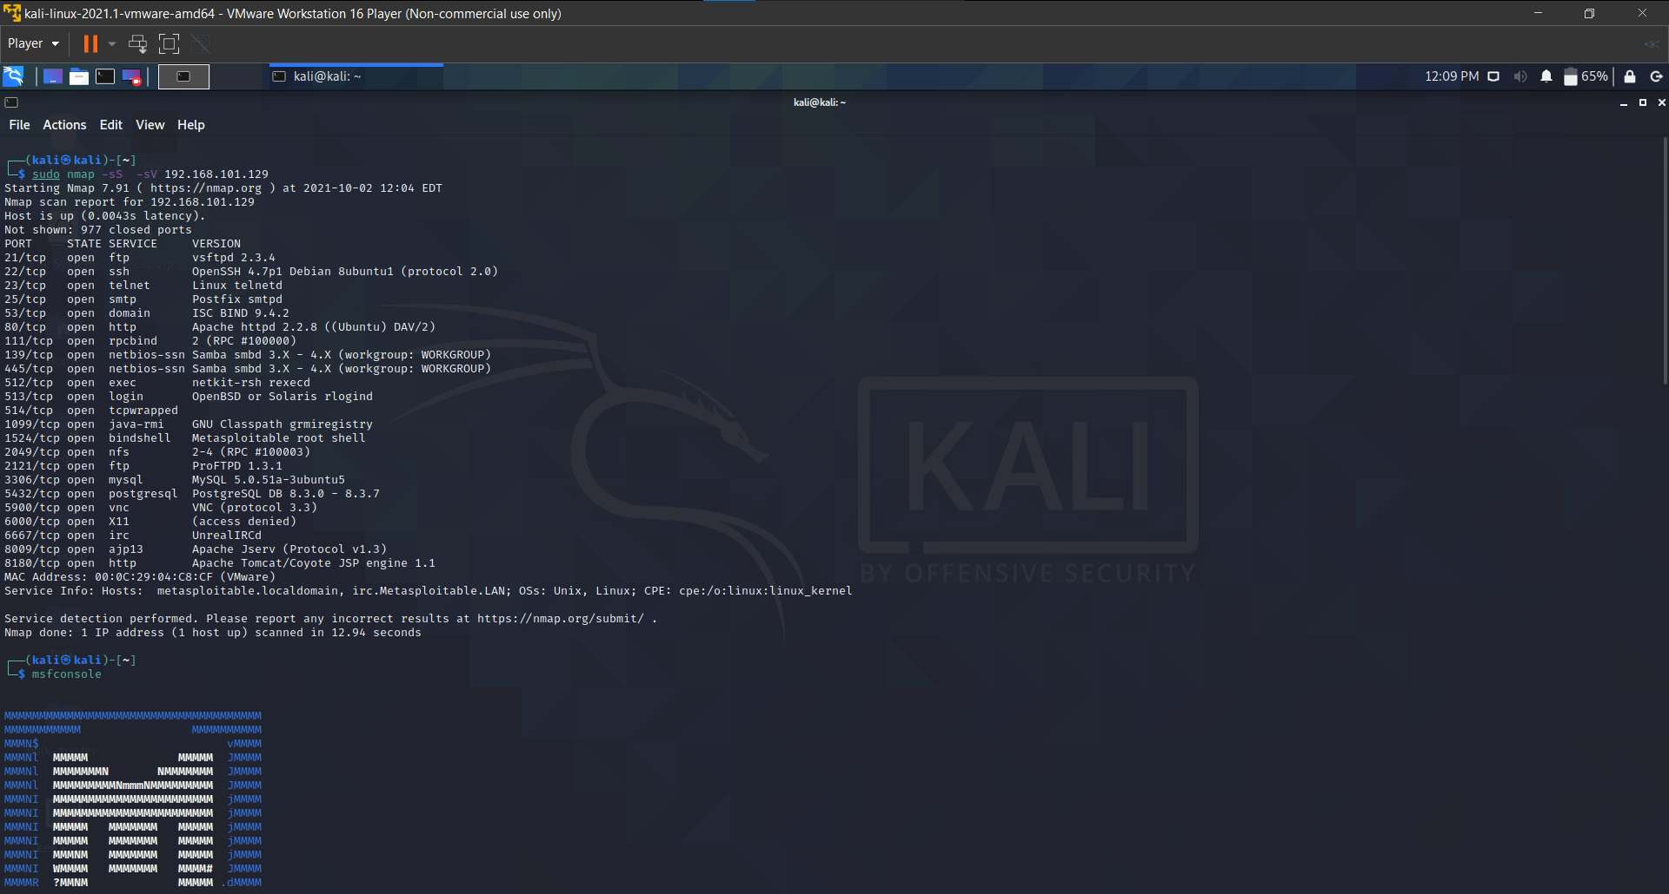

B) FTP

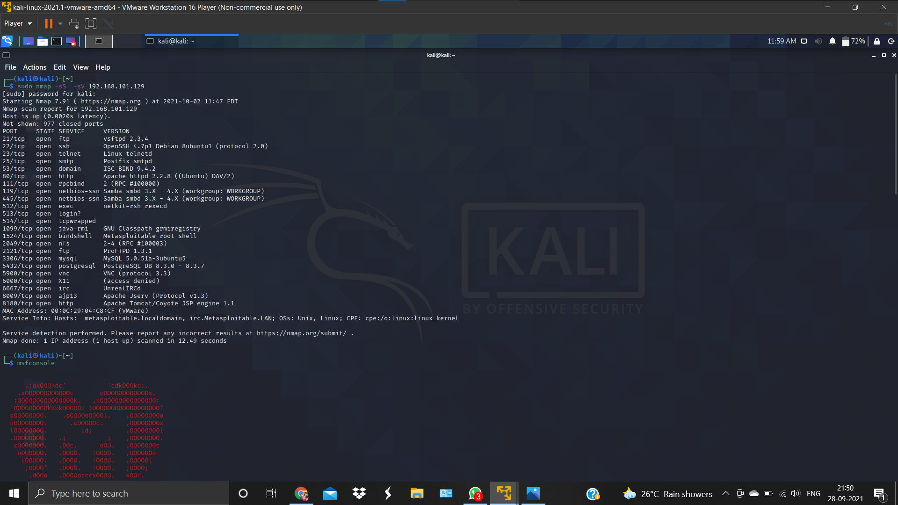

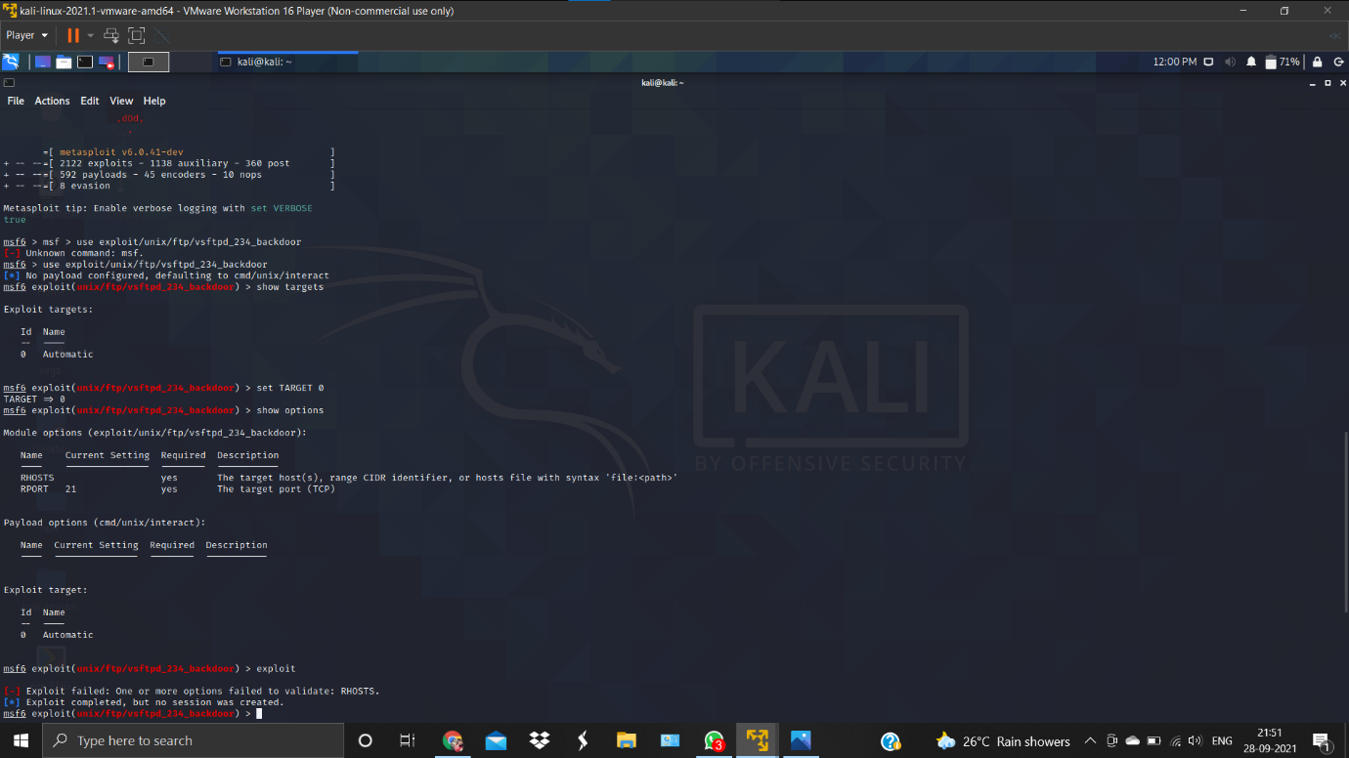

C) SSH

